CE2107 Lab2 Assignment Sheet (to be submitted to NTULearn before next lab)

Name:Mervyn Chiong Jia Rong Lab Group: SEP4 Date:

1. Section 6.2. Give a short 2-3 lines description on concept behind the reflectance reading process. Why does the black surface result in slower voltage decay?

**The reflectance of the surface will affect the “effective resistance” of transistor and in turn the decay rate of voltage on port 7 pins. As for why black results in a slower voltage decay is because there is lesser light on the base of the transistor therefore, conducting lesser**

1. Section 6.3. Where are the sources of the offset error between estimated and actual distance?

**Surface has uneven brightness, resulting in a slight margin of error due to reflectance reading**

1. Section 7.2.  Figure 7. The robot state toggled between LEFT and CENTER state repeatedly when it is detected that the robot is off to the left of the line (input: ‘01’). Under such condition, do you expect the robot to move toward the right in the zig-zag pattern or do you expect it to move in the smooth curve. Assume we shorten the time in each state from 500msec to 5 msec.

**The higher the wait time in each state that the robot has it will move smoother until a certain point where it degrades and goes back to a zig zag patter, since the wait time is now 5 the wait is much smaller hence the robot will contantly be in a state of transitioning from centre and left**

1. Section 7.3. Sketch the FSM diagram of your design that overcome the issue mentioned in this section. Label the FSM according to that shown in Figure 7. Take a photo/copy of your sketch and paste it here.

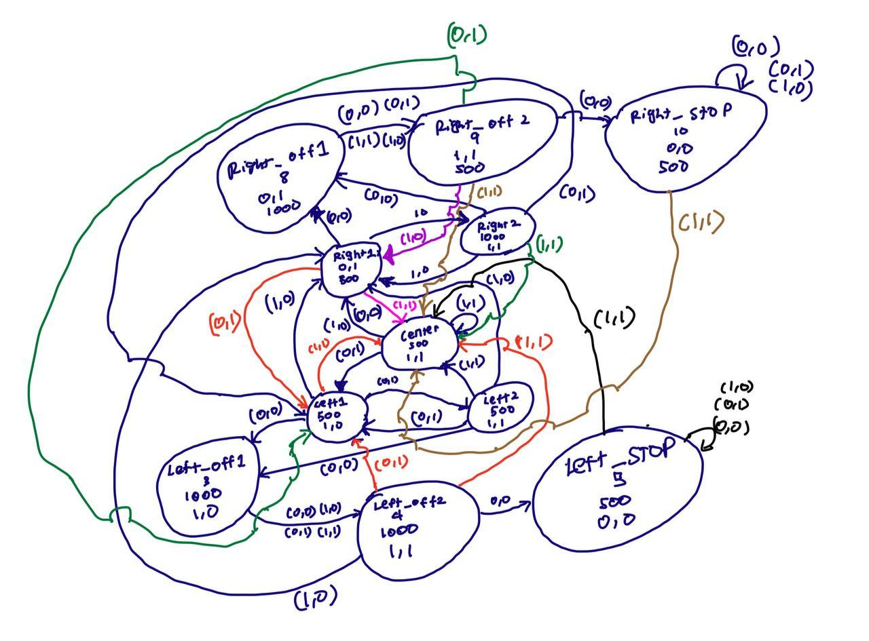

1. Section 7.3. Write down the procedure to initialise P2.4 to be an input pin with internal pull-up resistor

P2->SEL0 &=~0x10;

P2->SEL1 &=~0x10;

P2->DIR |= ~0x10;

P2->REN |= ~0x10;

P2->OUT |= ~0x10;

1. Section 7.3. Other than the List within List method used in the original Lab2_FSMMain.c, which other construct is commonly used to implement a FSM?

**Typedef structure**

1. Section 7.3. What is the purpose of toggling LED within the main routine or ISR?

**To show what state the robot is in**

1. Section 7.4. Which of the three functions Reflectance_Read(), Reflectance_Center() and Reflectance_Position() will give the best accuracy for the location of the robot with respect to the line?

**Reflectance_Center()**